## Project Title:

### Impact of AI on Student Learning

## Questions:

We have provided these questions:

* Query the teachers about following issues:
* Do you have any basic knowledge about AI tools?
* Have you ever used any AI tools?
* Will the unemployment increase in coming years due to AI modification?
* Which AI tool is mostly used for learning purposes?
* Have you personally experienced AI tools in education?
* Do you believe that AI has the potential to enhance the learning experience?
* In which subject do you think AI could be more beneficial?
* If you are related to the field of study, do you think AI can improve teaching methods?
* What are the potential challenges and risks of using AI in education?

## Questionnaire Preparation:

* Firstly, we asked our seniors what type of questionnaire we required. They explain us very well.
* After getting some idea about questionnaire we search it on internet.
* Moreover, we consulted with our teachers and parents?
* After all the research we are able to make this questionnaire.

## Department Selection:

We have selected the department of architectural engineering and design



### Reason:

The major reason of selecting this department is that Computer Science and Computer Engineering & design have very much common subjects, they both are the building block of new technology and both include designing.

## Collection Of Teachers Information:

* As computer science students, our first source of getting data is internet, we use UET official website: <http://www.uet.edu.pk/faculties/facultiesinfo/department?RID=faculty&id=1>
* Our second source was prospectus, we use it for the information of teacher’s designation and education
* After this we verify our information from our colleagues student of the department.

## Questionnaire filling:

* We used divide and rule policy and split our group into three small ones.
* Each group had authority letter to show it to teachers and convince them for filling the questionnaire.
* Teachers were very cooperative and nice.
* They give us very useful ideas and pointed out our mistakes in a very supportive way.
* Moreover, we had connections with the students of other universities, too.

## Data Approach

* We use email as it is used in google form for the validation of data
* We put forward the gender option for the specification of male and female faculty in our survey.
* Designation represents the type of people we are collecting from i.e chairman, assistant professor, lecturers etc.
* Qualification represents the education level of the people we are collecting data from.

## Consultation With Seniors:

Here we want to mention some of our seniors and we are very thankful to them for our guidance. They give us very useful and innovative ideas. Some useful tips for presentation.

* Afeera 2022-CS
* Faizan 2022-CS
* Abdul barr 2022-CS
* Saqib Amin 2022-CS

## Data Analysis By Using MS Excel Report:

### 1.Gender:

1. Male
2. 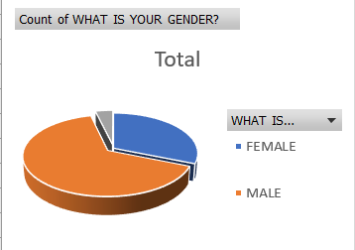Female

This graph shows that 66.7% respondents are males and 23.7% respondents are females and 3%

prefer not to say.

### 2.Knowledge about basics of AI:

1. Taught growing up
2. Very basic knowledge
3. No idea

This graph shows that 50% of our respondents are assistant professor and the other 50% are of lecturer

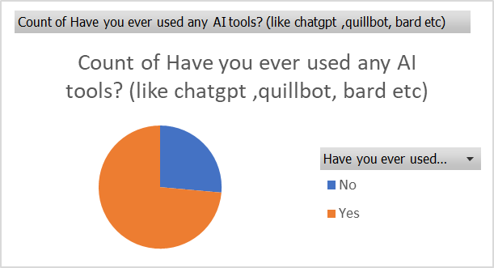

* 3 Have you ever used any AI tools?

### Yes

1. No

According to the gender analysis our majority questionnaire is filled by female teachers that of 73% male teachers are of 27%

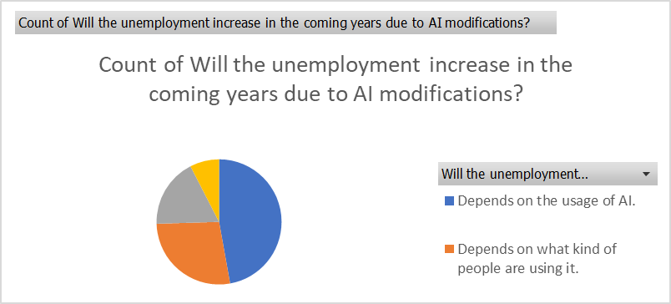

### 4. Will the unemployment increase in coming years due to AI modification?

a. depend on the usage of ai

b. depends on what kind of people use it

c. I have no idea

As the graph shows our major respondents are M.Sc that of 81.3% and Ph.D that of 18.8%

* 5. Which AI tool is mostly used for learning purposes?

### a. chatgpt

b. bard

c. quillbot

d. no idea

According to our survey the most used AI tool by students and even teachers was CHATGPT

* 6. Do you believe that AI has the potential to enhance the learning experience?

### a.it will modify the way we learn

b. it will provide opportunities

c. it will enhance the teaching capabilities of the teachers

7. In which subject do you think AI could be more beneficial?

### Discrete mathematics

### mathematics

1. C. quantum physics

9. What are the potential challenges and risks of using AI in education?

### They can have a bad effect on our thinking

1. They can have a good effect based on their usage
2. Rather not say

* From this chart we can state that 70% respondents think combine courses is an effective source and 20% consider it as ineffective and 10% rate it as N/A.
* Science and Engineering Department that of 80%.

## Conclusion:

We concluded that AI is helpful to a great extent, but, every thing has uses along with its abuses like it decreases the creativity of the students and it may take over a lot of jobs done by humans today.